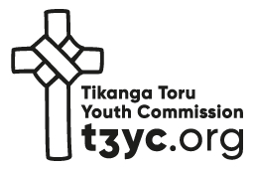
Tikanga Toru Youth Commission Report
For the 64th Session of GSTHW

“Discipling Young People to be Christ Centred in
the Three-Tikanga Church”
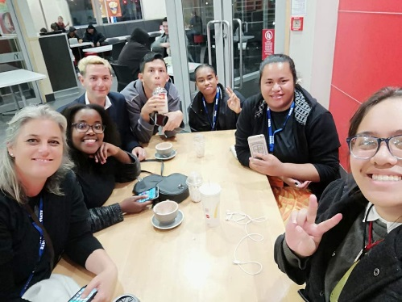
2018 Ministry Activity
TYS18, Auckland. – Inducted Jax Clark as Commissioner – Motions 8,9,10 moved to take to GS/THW.

Pononga - General Synod’s Stewards programme, New Plymouth, GS/THW18.

Raukura 18 for provincial youth enablers – Circle of Courage Youthwork Training, Auckland.

Youth Exchange was diverted to 2019 – rangatahi and leaders instead attend Discipleship training in Fiji / Tikanga Toru Presence at the Abby /Attendance at Ruatara Camp Northland.

Cross Tikanga attendance at each others events helped to build, renew and strengthen our three-Tikanga relationships with new commissioner and changing National Coordinators.
“Au vosa ni’u butuka tu
I speak from my place, because I have the right and know what I’m saying and am the best to speak for myself and my people”

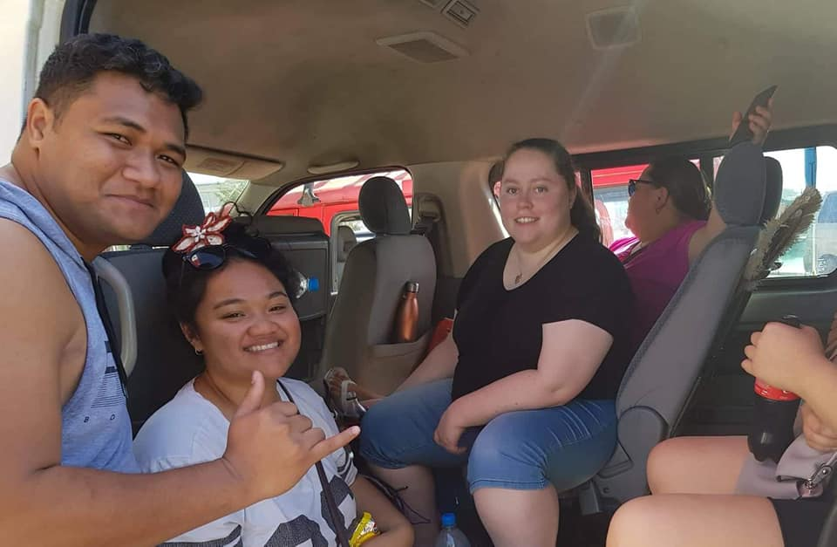
2019 Ministry Activity
TYS19 – St Johns College, Auckland NZ – a new Te Reo Maori initiative moved and passed. A theme of looking back to move forward accepted, with a robust discussion regarding the strategy of Tikanga Toru Youth Commission – decision to review strategy.

Raukura 19 – held in Tonga with delegates from Tikanga Pakeha and Tikanga Maori further as part of Polynesia’s Discipleship Training – further strengthened and educated young people on our Three-Tikanga relationship and the challenge of Identity and Discipleship.

TYE19 – Coordinated this year and hosted by the Commission Team located in consultation with Waikato and Te Manawa o te Wheke – a solid educational experience for both Rangatahi and Commision members in how to navigate leadership, cross cultural partnership and the importance of wellbeing. Big lessons learnt as we sought to run the event in partnership with Tikanga Maori.

Staffing Jax Clark has been the Tikanga Toru Commissioner for thel ast 2 years, but has since resigned to attend St John’s Theological College starting in Feb 20. Jax took a 5 month bereavement leave period in 2019. Aleshia Lawson will continue as Marketing and Communications Corodinator and in the interim the National Youth coordinators will manage the Commission, and will oversee the appointment of a new Commisioner.

Strategic Direction – TYS 2020
Prior to her departure Jax provided the commission with a set of recommendations to adapt the way in which the youth commission structure unction together to create;

- Better youth voice and youth led ministry activity from the commission.
- A more supportive and connected commission and therefore structure around the commissioner.
“Me hoki whakamuri kia anga wakamua
We must look back to move forward”

To manage through the transitional period and prior to advertising for a new commissioner, the commission undertook to:
- Recommitt to the purpose of the TTYC as stated in the Canon. i.e to suppport 3 Tikanga youth ministry and to see that flourish for the benefit of our church.
- Seek feedback from TYS to provide direction for the future of the T3YC. (Appendix 1)
- Committ to providing better support and orientation to the incoming commission members.
- Provide clear leadership and pastoral support for the commissioner. To communicate this to General Synod Standing Committee and ensure a closer working relationship with GSSC.

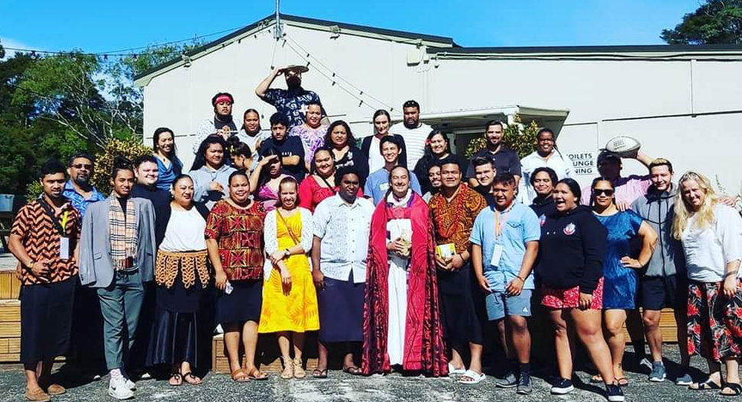

Creativity Motion TYS young people challenged the incoming TTYC to give more space, opportunity and priority for creative gifts and expression of youth within the commission program,TYS supported the desire of young people to express their creative gifitings as a way of enhancing their worship in God and relationships as young people and as a church. There was also a challenge to the commission to prioritise the creating of safe spaces and dialogue for minority groups.

Environment Motions Tikanga Polynesia where successful with motions presented at TYS. Those motions focused on rolling out CIVA GIS training with Tikanga Maori and Tikanga Pakeha in successive years. And calling on GSTHW to endorse the priorities that TYS have identified for the Youth of the Church:
  - Focus on oceans
  - Focus on climate resilience
  - Focus on sustainable livelihoods
A third motion identified the need for GSTHW to progress the implementation of the blessings of same gender relationships. And a final motion was for the resourcing of an indigenous languages commission.

On a personal note Thanks to those who were passionate about the liberation of young peope in our province, the TTYC was established and disciple young people and to ensure their voice is heard.


Across the last 2 years 150 young people from our province have attended with Tikanga Toru Youth events. The challenge is that some have attended more than one, and what happens after the event? A change in leadership is always a good opportunity to review strategy and mission. I strongly advocate for a youth led ministry team supported by katiaki / guardians from each Tikanga and leave the challenge for the Commission and GSSC to embrace new and fresh ministry ideas that ensure activity truly does disciple young people and challenges both youth and the wider church to lean into robust and authentic Three-Tikanga relationships. At times this will mean making way for the other, and taking risks into new terriority to see what prodcues the most fruit.

I am confident that the wisdom and passion and investment that sits now with the current Commission members will see a strategy emerge that honours the past and navigates its way into a bright future. I would also urge this team to ensure that their thinking includes the youth voice to be heard at TYS19 and to keep navigating their way into new terriority while honouring the past.

I have learnt so much about richness of our three-Tikanga church and will be forever grateful for the opportunity to bring all of who I am and be shaped and challenged in this role.

Nga mihi nui,
Jax Clark - Tikanga Toru Youth Commissioner

